**House Number** 7

Bansko, Blagoevgrad district, 4, Garibaldy

GPS N 41°50'09.9" and E 23°29'09.0"

The house is with 4 floors with basement. The stairs are internal stairs for a building. The family lives on 2 and 3 floor on the other floors nobody lives and they are empty.

TMH (green) – 5; PCH (brown) – 4; MDC (Yellow) – 5 numbers; MCH (black) – 8 numbers

relevant GTS

relevant GTS

Pair CATS – 9 numbers

We not put 1 PCH brown from the planned one for this house.

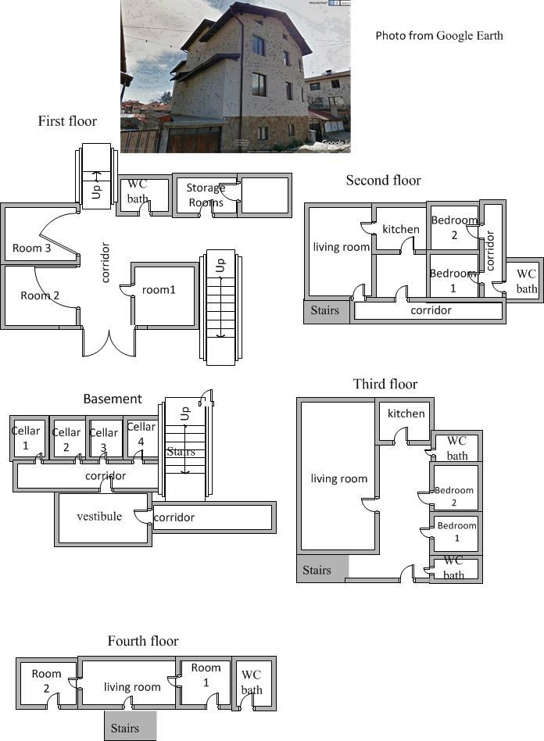

1